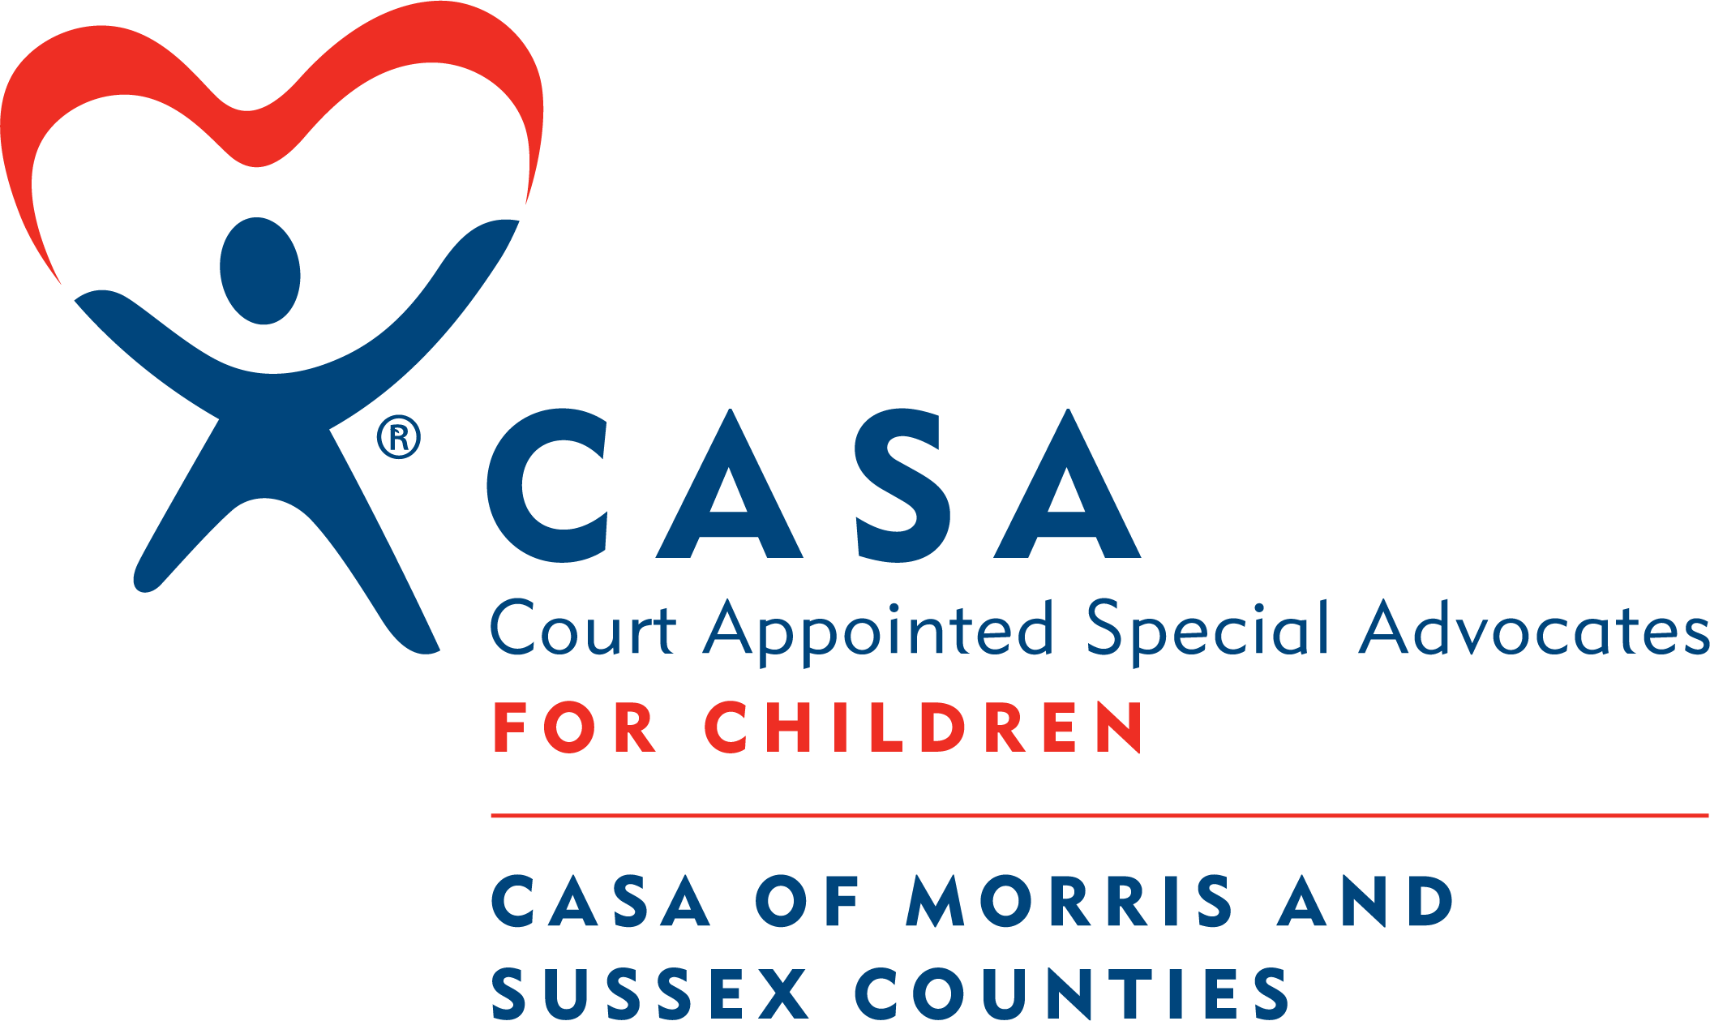

CASA of Morris and Sussex Counties, Inc.

POSITION: Executive Assistance/Office Manager

REPORTS TO: Executive Director
LOCATION: 222 Ridgedale Avenue, Cedar Knolls, NJ

GENERAL DESCRIPTION:
The Executive Assistant/Office Manager provides support for the Executive Director and CASA staff, volunteers, and Board of Trustees. Responsibilities include front desk reception coverage; overseeing daily office operations, managing administrative operations of office equipment; processing donations (checks, credit cards, and venmo); completion of documents for Executive Director; completing financial functions such as payroll, spreadsheets, and audit preparation, and assisting the Executive Director with preparation for outreach and fundraising events.

QUALIFICATIONS:
- Computer skills with a concentration in Microsoft Office to include: Word, Excel, Outlook, and Power Point
- Knowledge of QuickBooks operations
- Knowledge of a donor management system is a plus
- Ability to execute mail merge
- Strong interpersonal skills, professional and courteous demeanor, excellent office and phone etiquette and organizational skills
- Able to handle multiple tasks and work independently
- Organizational skills with accuracy and attention to detail
- Ability to work well under pressure and navigate multiple deadlines
- Proactive approach to problem-solving and process improvement
- Ability to work well independently and in collaboration with others
- Should have a minimum of 3-5 years of work experience in similar administrative capacity

RESPONSIBILITIES:
- Provide high-level confidential support to the Executive Director
- Provide administrative assistance in finance (payroll through ADP, paying bills, audit preparation) and human resources (documentation for onboarding new staff)
- Process donations (checks, credit cards, and venmo)
- Complete correspondence for Executive Director including thank you letters
- Coordinates annual Holiday Wish Lists for various donor sources
- Work with sensitive information with to maintain confidentiality and security and ensure compliance with privacy policies and regulations
- Assist Executive Director and Development Director with fundraising and outreach events
- Ensure that deadlines are met and adapts to changing priorities.
- Coordinate logistics for meetings, including room setup and catering
- Operate and maintains office equipment, including printers, copiers, and fax machines

EMPLOYEE CLASSIFICATION: Full Time in-person

GENERAL REQUIREMENTS:
- Satisfactory Background checks (Fingerprinting, CARI, etc.)
- References
- Successful completion of 36 hour CASA Volunteer Training (completed after hire)

ABOUT OUR WORKPLACE:
At CASA of Morris and Sussex Counties our team is driven by a commitment to excellence and thrives in a dynamic and inclusive workplace. Our motivation is serving the best interest of children in the foster care system. We believe in promoting a positive work environment founded on professionalism and integrity, where open communication and continuous learning are encouraged. If you appreciate teamwork, value diversity, and are committed to the highest workplace standards, CASA is the perfect place for you.
CASA of Morris and Sussex Counties is deeply committed to a policy of equal employment opportunity for all of its applicants and employees. We recognize the value of diverse experiences, identities and backgrounds and are committed to building an equitable, inclusive and anti-racist organization that is representative of the world in which we live. Candidates who identify as Black, Indigenous or a Person of Color; LGTBQ+ and gender diverse candidates; candidates with disabilities; as well as candidates from historically marginalized groups are all encouraged to apply. We aim to collect a pool of diverse and qualified candidates.

